**Experiments -1 Installation of GIMP AND BLENDER.**

**Installation of GIMP:**

**Step - 1:**

Download the GIMP installer. You can download this for free from gimp.org/downloads

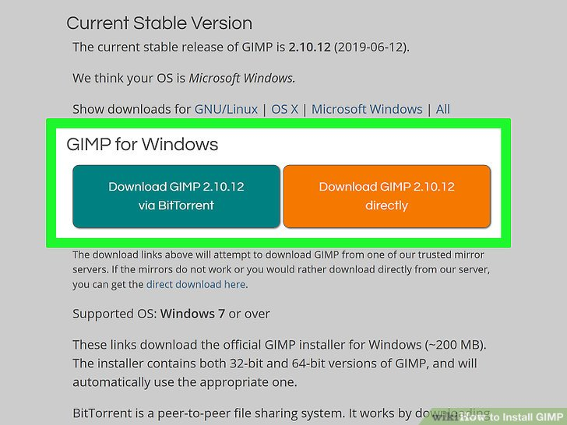

**Step – 2:**

Run the GIMP installer. You can find this at the location you saved it to, usually your Downloads/My Downloads folder.

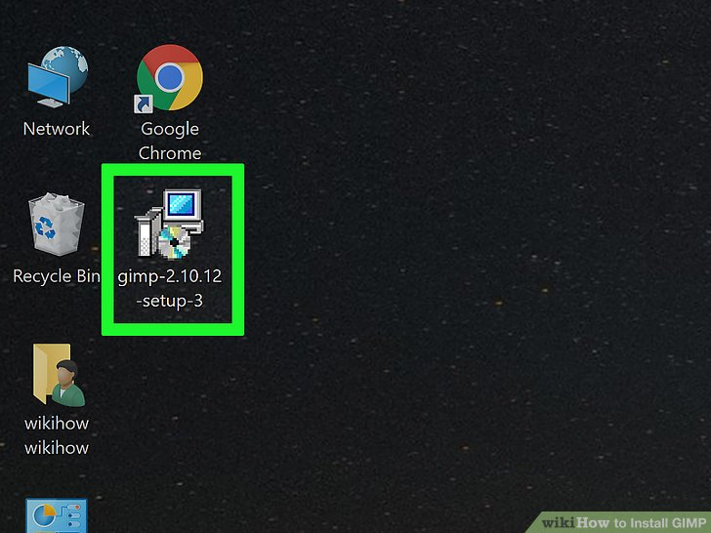

**Step – 3:**

Follow the prompts to install GIMP. Most users can leave the settings at the defaults.

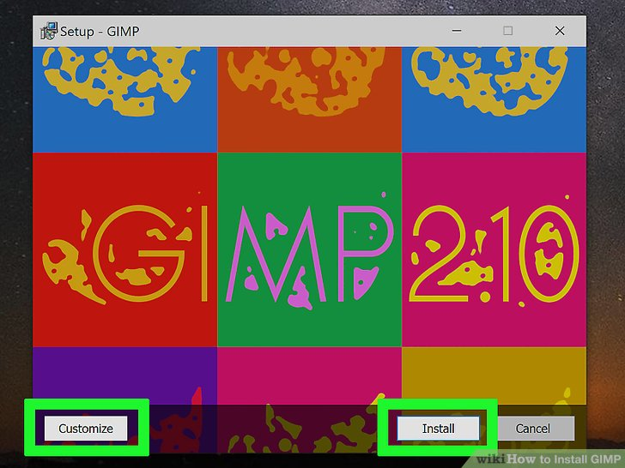

**Step – 4:**

Finish the installation. After selecting the file formats, GIMP will install. This may take a few minutes.

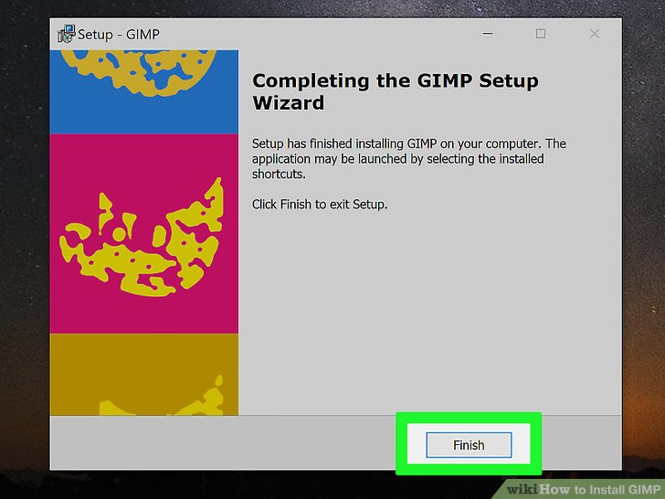

**Step – 5:**

Start using GIMP. Once GIMP has finished installing, you can start using it.

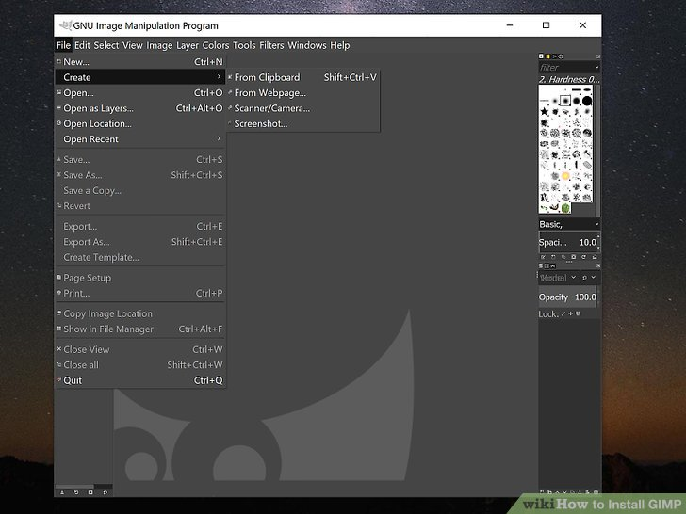

**Installation of BLENDER:**

**Step – 1:**

Visit the Blender Website.

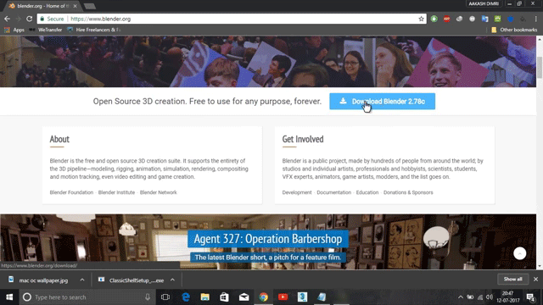

**Step – 2:**

Click on the link to access the Download page. Also, select the operating system to install the program.

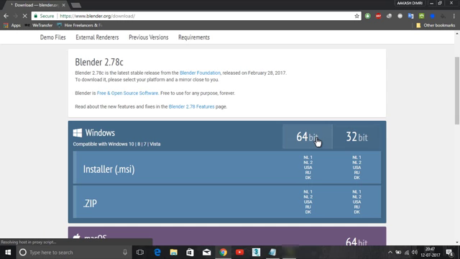

**Step – 3:**

Now, run the downloaded Installer which will probably be available in the download folder.



**Step – 4:**

Now, click on the Next Button to initiate the installation process.

**Step – 5:**

Click on the Next Button, when asked to move ahead in the process.

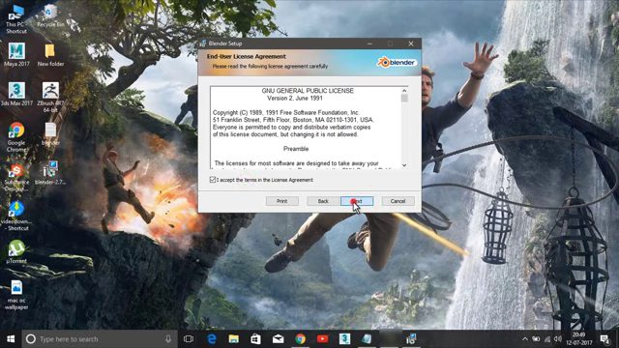

**Step – 6:**

In this step, the user can change the default location of the program. Click Install to Move ahead.

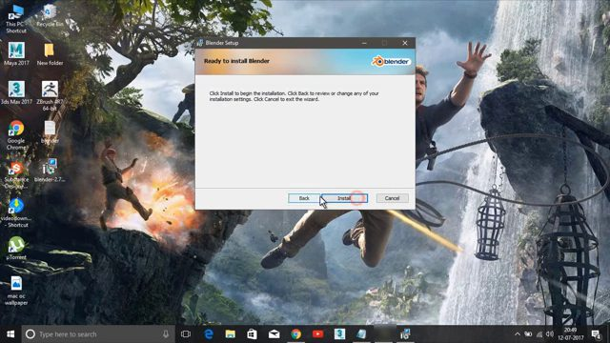

**Step – 7:**

Wait for the Program to Install Blender.

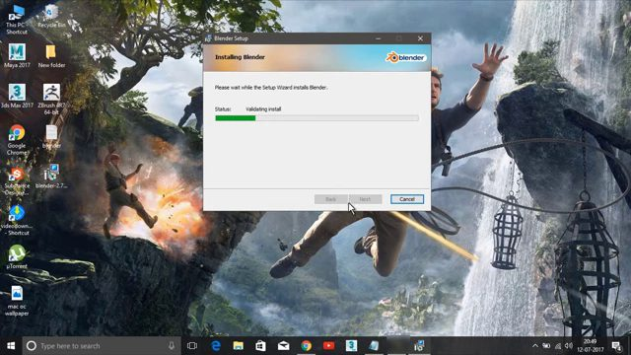

**Step – 8:**

Click on Finish and complete the Installation Blender process.

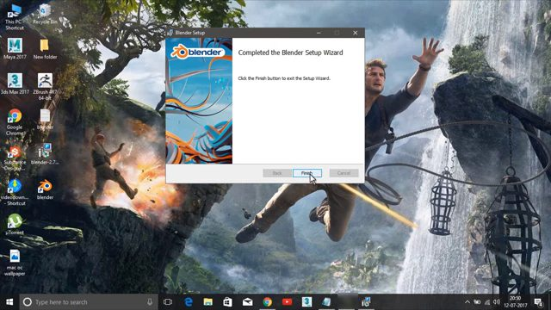

**Step – 9:**

After installing the program, the Blender window will look like this. The interface of Blender is the same across all the operating systems.